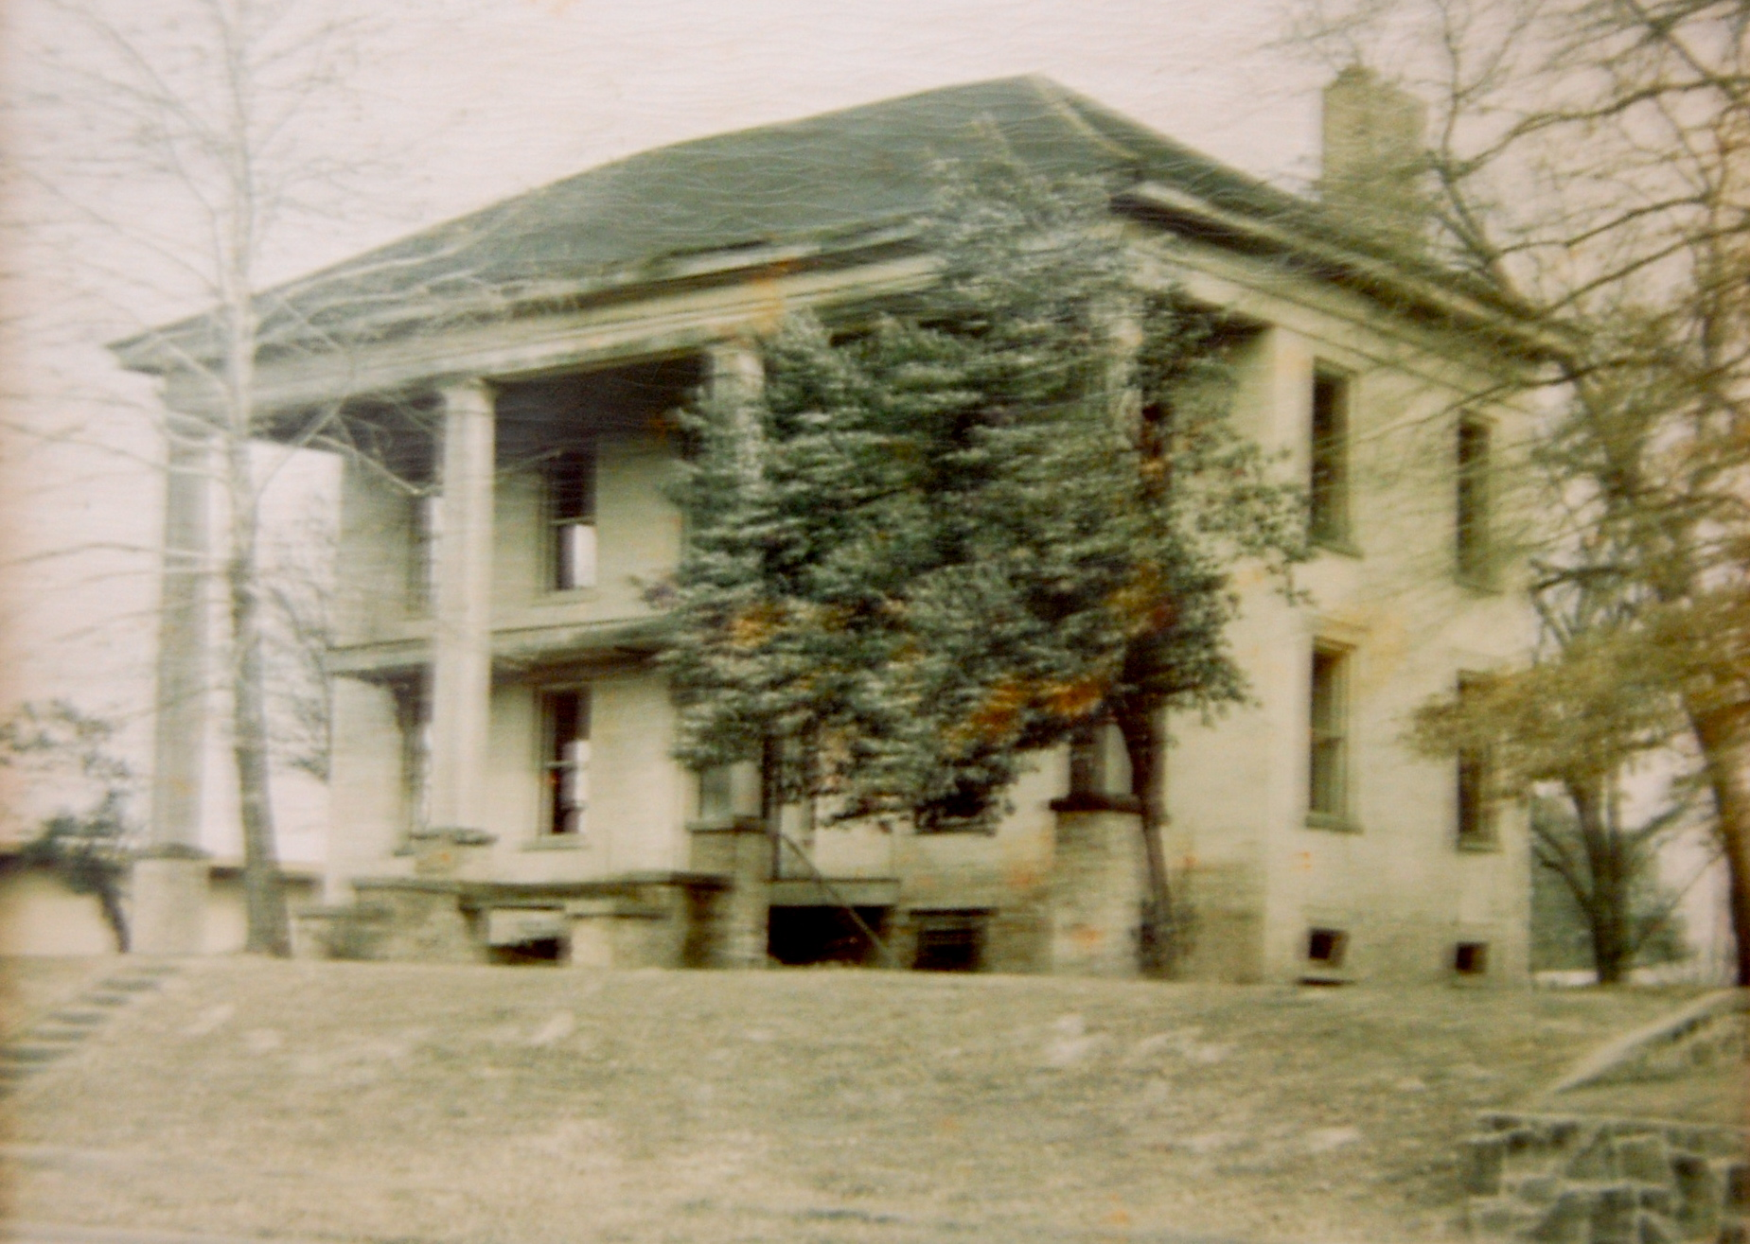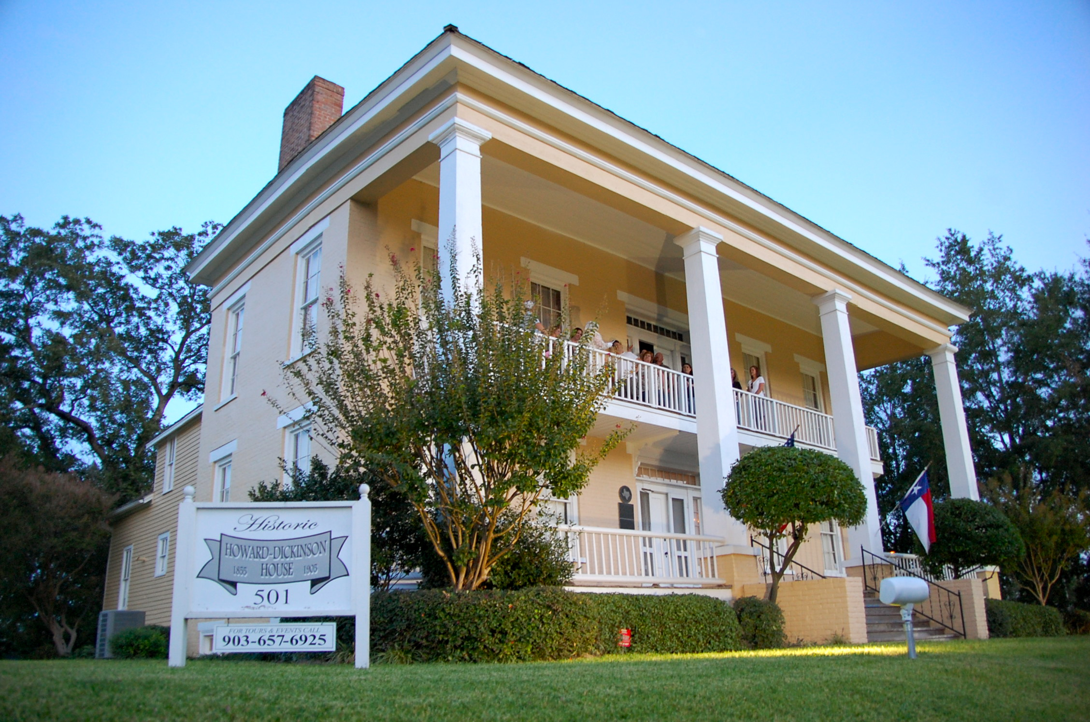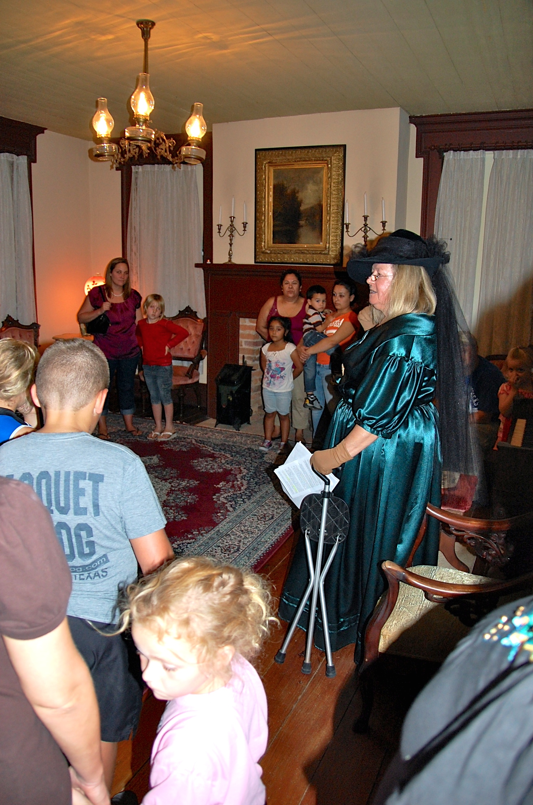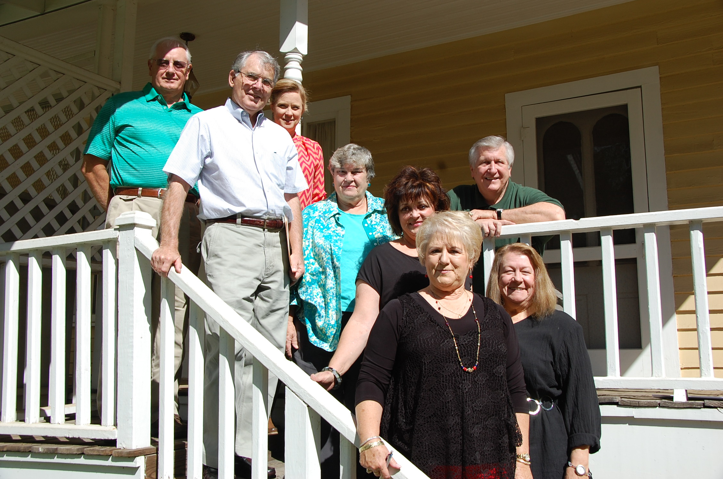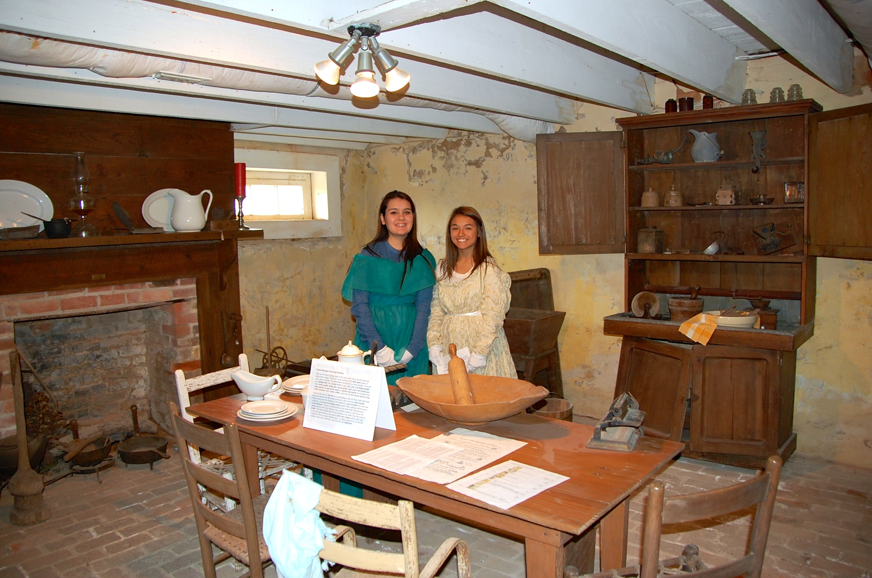

www.howardhousehenderson.org

Fall/Winter 2014-2015

Rusk County Heritage Association PO. Box 2434 Henderson, TX 75653

See page two

**Greetings to all who value the past:**

**The Rusk County Heritage Association, caretakers of the 1855 Howard-Dickinson House on South Main in Henderson, invite you to play a part in keeping the house for future generations to enjoy. Become a Friend today by mailing a check along with the form on the back of this newsletter.**

**Awarded a Texas Historical Medallion in 1968, the home was once abandoned, a ghost of its glorious past as one of the proudest homes in Henderson – a place that hosted Sam Houston on several occasions. It was only through a hard-fought battle by the newly organized Rusk County Heritage Association that the house was saved in the 1960s.**

**Today, the battle continues, as funding is needed for ongoing maintenance. Board members, tour docents and other volunteers are also needed. Please be a hero for local preservation by playing a part.**

**The Howard-Dickinson House is open by reservation for tours and is available to be rented for parties, weddings, reunions, receptions, meetings and other occasions.**

**Call 903-657-5906 or 5528 or see www.howardhousehenderson.org.**

The house before restoration, circa 1960.

# Tours, rentals keep HDH in use

Your help is crucial in preserving this valuable icon of our town’s past.

Friends of the historic

Howard-Dickinson House

Vivamus porttitor augue eu lorem. Proin facilisis nulla non mauris.

Lorem

### Vivamus

**Ongoing expenses include utilities, insurance, landscape and building maintenance and interior cleaning. Other recent items have been interior painting, repair of the electric lift for the disabled, preventative termite treatment, water heater repair, AC/Heat system repair, and repairs to the front porch railing and to the roof after a lightning strike. Fortunately, there was no fire!**

**The house is always open by appointment for tours and can be reserved for events by calling 903-657-5906 or by calling the Henderson Area Chamber of Commerce at 903-657-5528.**

**The house is open during Syrup Festival and on scheduled Home Tour Days. School groups are especially encouraged to visit.**

**YES! I want to be a FRIEND of the Howard-Dickinson House!**

**Name:**

**Address:**

**E-Mail:**

**I am interested in:**

**Enclosed is:**

**$25 Individual $50 Family $100 Corporation/Organization**

**$ Other**

**Make Checks to Rusk County Heritage Association and mail to P.O. Box 2434, Henderson, TX 75653. Your donation is tax deductible. *Thank you for your support!!***

**Historical Tours and Ghost Tours are popular at the house. Members of the HHS Key Club have been appreciated as volunteer docents as shown below.**

**Board members of the Rusk County Heritage Association include, from left, Charlie Gambrell, Tom Laney, Darla Cloutier, Linda McKinney, Carol Young, Art Rousseau, Judy Sewell and Joan Smith. Not pictured are Woodie Tipps, Joe Koch, Suzanne Cross and Cyndi Walker.**